How IQ is measured: Index Scores

The graph below shows a how scores on IQ tests are distributed amongst humans.
Number of people | 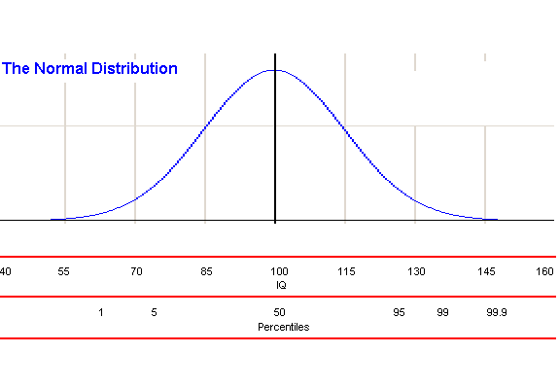
The highest point in the graph is the point where the IQ score is 100. This is the average score on an IQ test. When many of people are tested using the same test, the average score that they will get on that test as a group will be very close to 100.
But as you can see on the graph, individual scores can actually vary across a wide range. Individual children who are tested using the WISC-IV or WPPSI-III can get scores ranging from 40 to 160.
Different ranges of scores on these tests are categorized as follows:
Score | Category | Number of people who have scores in this range
Below 90 | Extremely low | 2.2 out of 100
Below 90 | Borderline | 6.7 out of 100
Below 90 | Low Average | 16.1 out of 100
90-109 | Average | 50 out of 100
Above 109 | High Average | 16.1 out of 100
Above 109 | Superior | 6.7 out of 100
Above 109 | Very Superior | 2.2 out of 100
Your child’s report will give the category that his/her results are in, and the percentile rank of their result. A percentile rank shows a person’s result compared to others in the same age group. A person who obtains a percentile rank of 35 has scored as well as, or better, than 35% of people in the same age group (and therefore lower than 65% of people in the same age group).
On the WISC-IV and WPPSI-III, scores that fall between the 25th and 75th percentile ranks are within the average range

How IQ is measured: Subtest Scores

Wechsler subtests – categories and percentiles

Scaled score | Percentile | Category
1-4 | <1 - 2 | Well below average
5 - 7 | 5 - 16 | Below average
8 - 12 | 25 - 75 | Average
13 - 15 | 84 - 95 | Above average
16 - 20 | 98 - >99 | Well above average

